Test Case: tc001_SPX_Dev5_Crear_Requisicion_Spot_Tipo_Cobro_CC
Step 1 - Enter username and password and click to button Enter : Credentials Entered
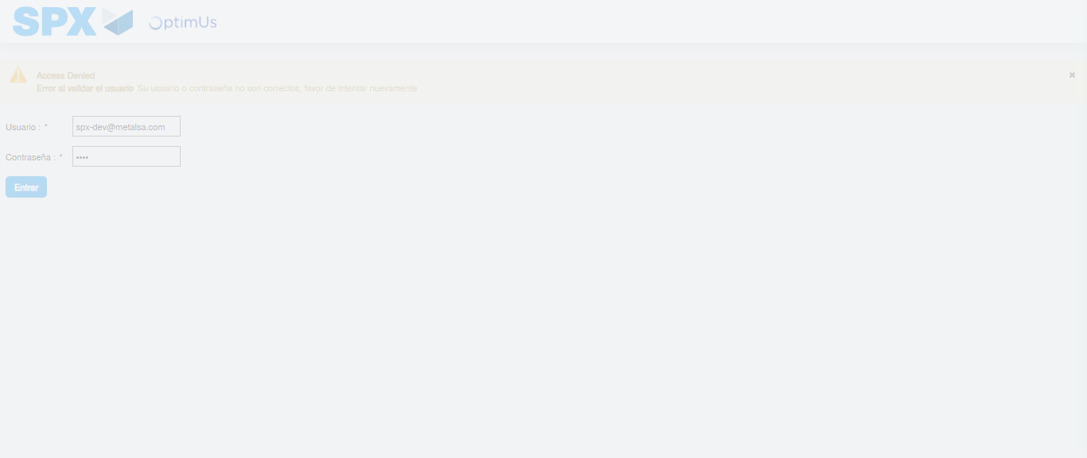Image file-name: QC_Testing-tc001_SPX_Dev5_Crear_Requisicion_Spot_Tipo_Cobro_CC-1783980045220

Step 2 - Select to UEN and Access to Spot Buy Requisitions : UEN Correctly selected and Correct access
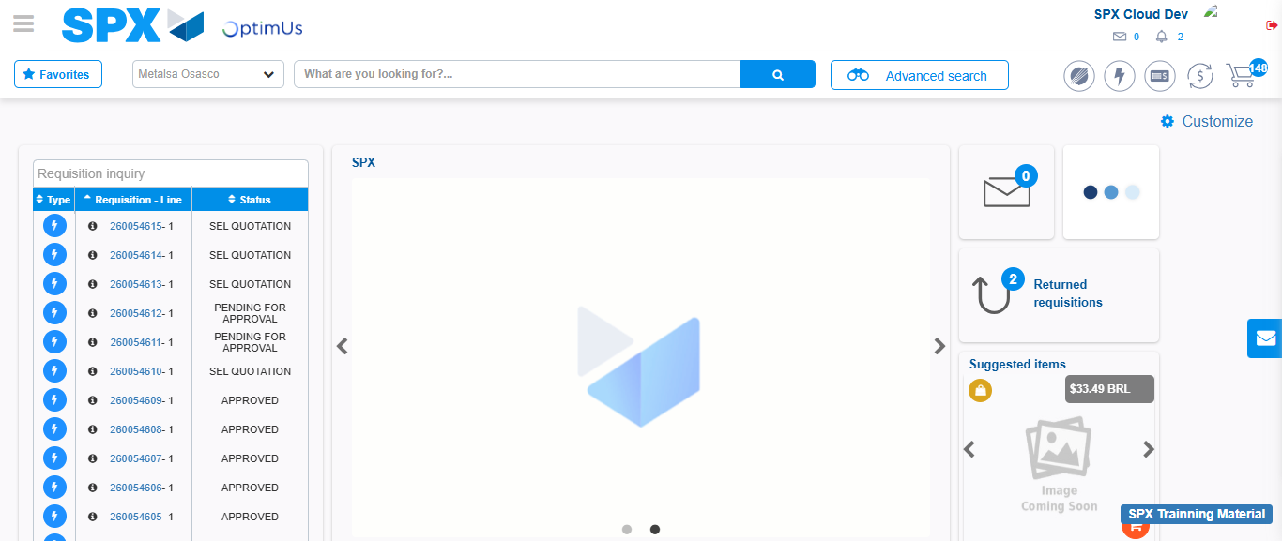Image file-name: QC_Testing-tc001_SPX_Dev5_Crear_Requisicion_Spot_Tipo_Cobro_CC-1783980071306

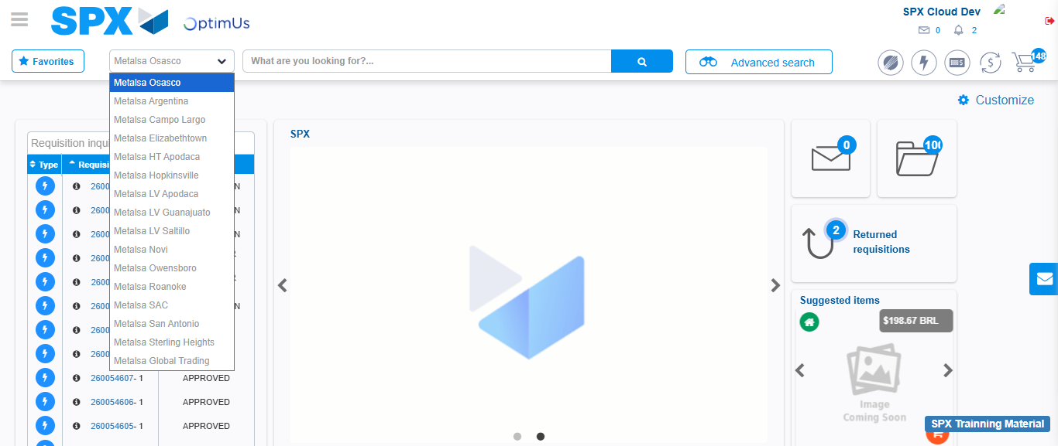Image file-name: QC_Testing-tc001_SPX_Dev5_Crear_Requisicion_Spot_Tipo_Cobro_CC-1783980073831

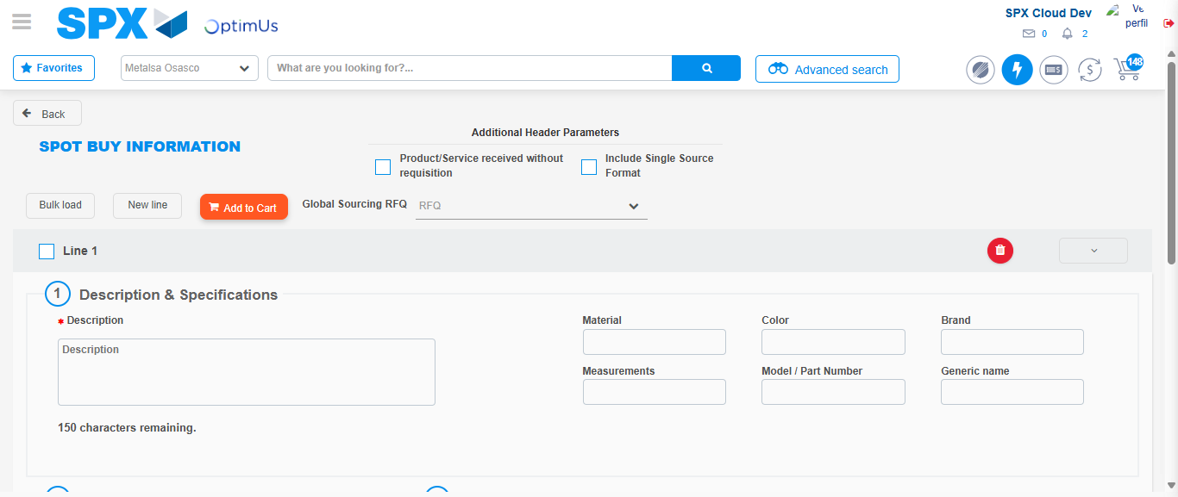Image file-name: QC_Testing-tc001_SPX_Dev5_Crear_Requisicion_Spot_Tipo_Cobro_CC-1783980095659

Step 3 - Data Capture Spot Buy Requisition : Data captured correctly
Image file-name: QC_Testing-tc001_SPX_Dev5_Crear_Requisicion_Spot_Tipo_Cobro_CC-1783980095890

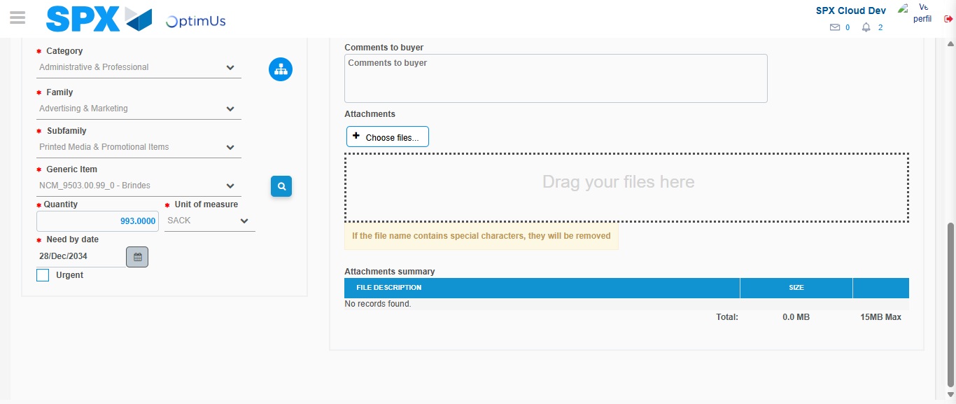Image file-name: QC_Testing-tc001_SPX_Dev5_Crear_Requisicion_Spot_Tipo_Cobro_CC-1783980108134

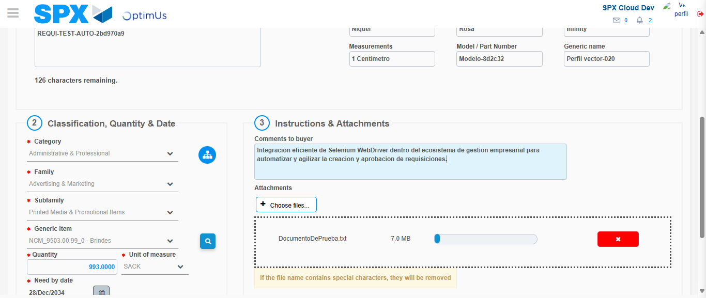Image file-name: QC_Testing-tc001_SPX_Dev5_Crear_Requisicion_Spot_Tipo_Cobro_CC-1783980108898

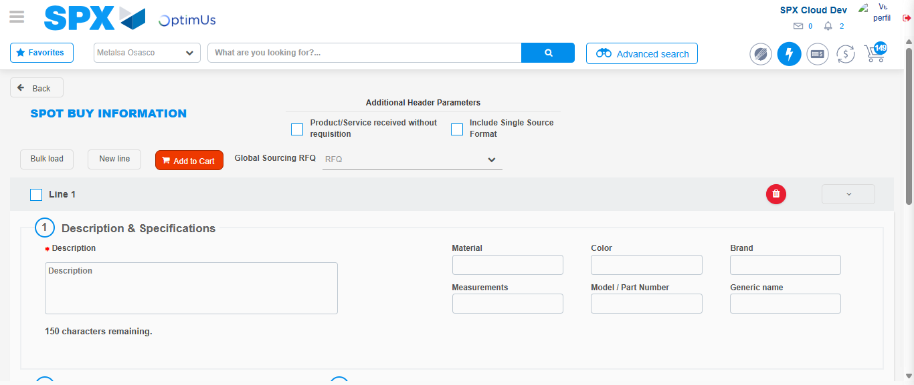Image file-name: QC_Testing-tc001_SPX_Dev5_Crear_Requisicion_Spot_Tipo_Cobro_CC-1783980118363

Step 7 - Return to Main Page SPX : Return to Main Page SPX
Image file-name: QC_Testing-tc001_SPX_Dev5_Crear_Requisicion_Spot_Tipo_Cobro_CC-1783980071306

Image file-name: QC_Testing-tc001_SPX_Dev5_Crear_Requisicion_Spot_Tipo_Cobro_CC-1783980073831

Image file-name: QC_Testing-tc001_SPX_Dev5_Crear_Requisicion_Spot_Tipo_Cobro_CC-1783980095659

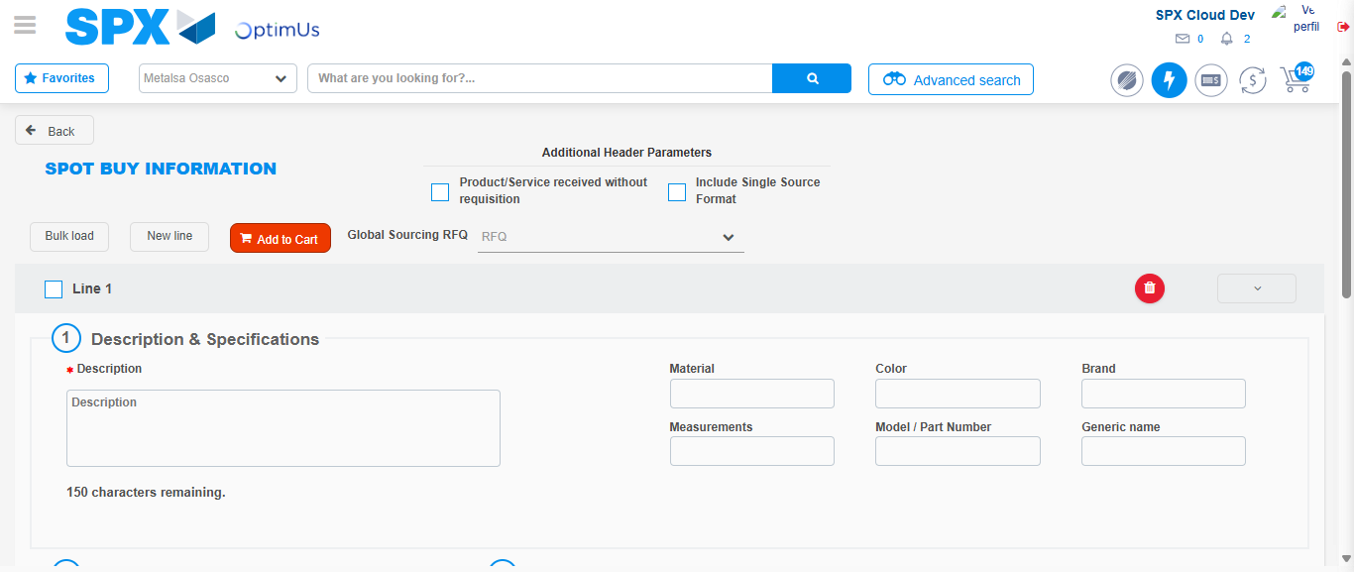Image file-name: QC_Testing-tc001_SPX_Dev5_Crear_Requisicion_Spot_Tipo_Cobro_CC-1783980120572

Image file-name: QC_Testing-tc001_SPX_Dev5_Crear_Requisicion_Spot_Tipo_Cobro_CC-1783980120756

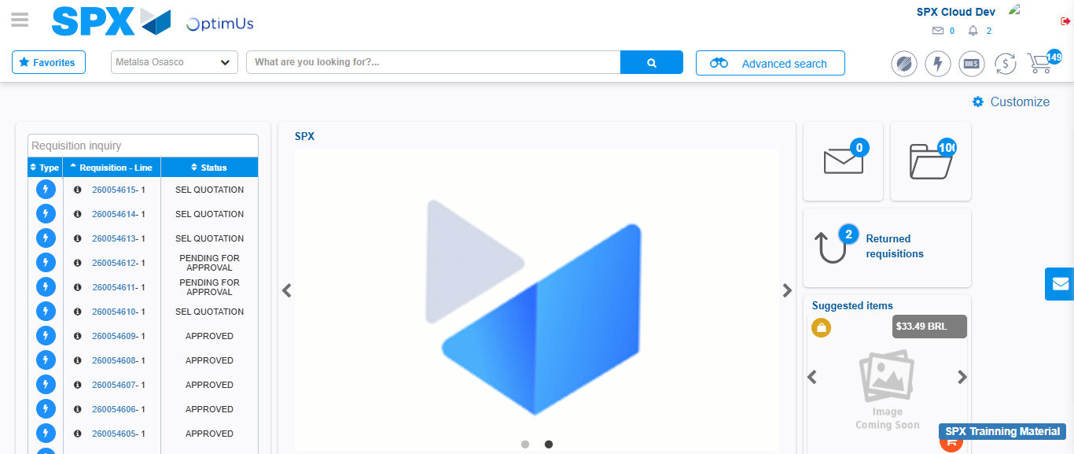Image file-name: QC_Testing-tc001_SPX_Dev5_Crear_Requisicion_Spot_Tipo_Cobro_CC-1783980141754

Step 8 - Log Out : Log Out SPX
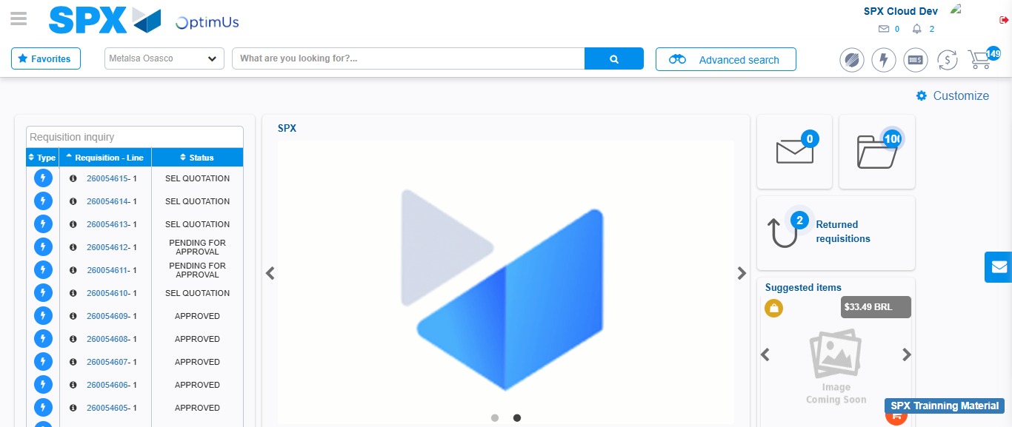Image file-name: QC_Testing-tc001_SPX_Dev5_Crear_Requisicion_Spot_Tipo_Cobro_CC-1783980142038

